Section 11

Set A | Set B
Let Σ = {0, 1}. Now consider the following languages over Σ.
L₁ = {w : w starts with odd number of 1’s}  L₂ = {w : w starts and ends with the same symbol}  L₃ = {w : every second symbol of w is 0}  L₄ = {w : length of w is at most 5} | L₁ = {w : w starts with odd number of 0’s}  L₂ = {w : w starts and ends with the same symbol}  L₃ = {w : every second symbol of w is 1}  L₄ = {w : length of w is at most 5}
- Write the regular expression for the language L₁ . [2 Points]
- Write the regular expression for the language L₂ . [2 Points]
- Write the regular expression for the language L₃ . [2 Points]
- Design a DFA for the language L₁ . [2 Points]
- Design a DFA for the language L₂ . [2 Points]
- Design a DFA for the language L₃ . [2 Points]
- Write all strings in L₁ ∩ L₂ ∩ L₃ ∩ L₄ . [2 Points]
- If you have to use the cross product operation for L₁ ∩ L₂ ∩ L₃ ∩ L₄ then how many states you will need? [1 Point]

Set A | Set B
- (11)*10Σ* | (11)*1  - 0Σ*0 | 1Σ*1 | 0 | 1  - (Σ0)*(0|1|ε)  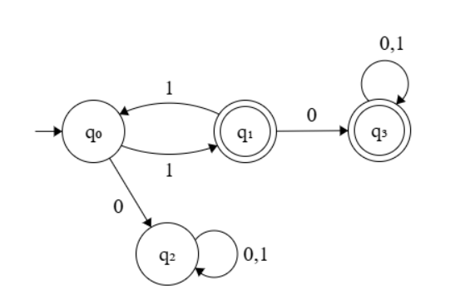 | - (00)*01Σ* | (00)*0  - 0Σ*0 | 1Σ*1 | 0 | 1  - (Σ1)*(0|1|ε)  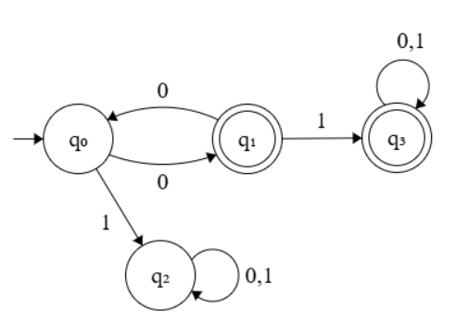
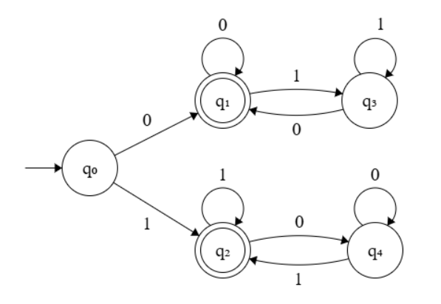

Set A | Set B
f)  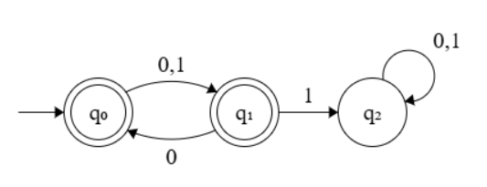  g) 1, 101, 10001, 10101  h) 4 x 5 x 3 x 7 = 420 | 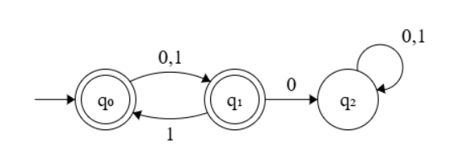  - 0, 010, 01110, 01010  - 4 x 5 x 3 x 7 = 420

Section 12

Set A | Set B
Let Σ = {0, 1}. Now consider the following languages over Σ.
L₁ = {w : number of 0’s in w is divisible by 3}  L₂ = {w : w starts and ends with 1}  L₃ = {w = 10^{m}1 ; where m is one more than multiple of 3}  L₄ = {w : length of w is exactly 5} | L₁ = {w : number of 1’s in w is divisible by 3}  L₂ = {w : w starts and ends with 0}  L₃ = {w = 01^{m}0 ; where m is one more than multiple of 3}  L₄ = {w : length of w is exactly 5}
- Write the regular expression for the language L₁ . [2 Points]
- Write the regular expression for the language L₂ . [2 Points]
- Write the regular expression for the language L₃ . [2 Points]
- Design a DFA for the language L₁ . [2 Points]
- Design a DFA for the language L₂ . [2 Points]
- Design a DFA for the language L₃ . [3 Points]
- Write all strings in L₁ ∩ L₂ ∩ L₄ . [1 Point]
- If you have to use the cross product operation for L₁ ∩ L₂ ∩ L₄ , then how many states you will need? [1 Point]

Set A | Set B
- (1*01*01*01*)* | 1*  - 1Σ*1 | 1  - 1(000)*01  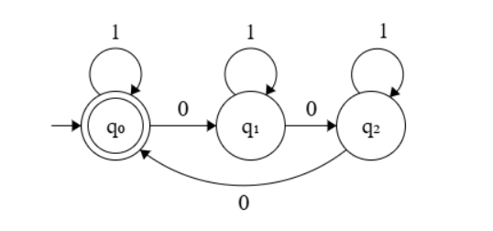  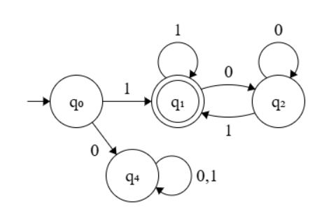 | - (0*10*10*10*)* | 0*  - 0Σ*0 | 0  - 0(111)*10  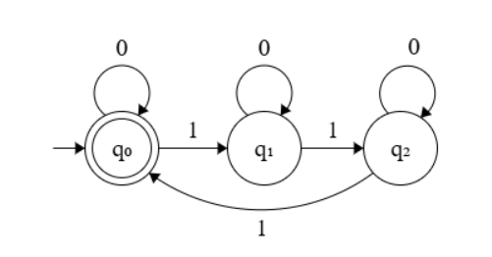  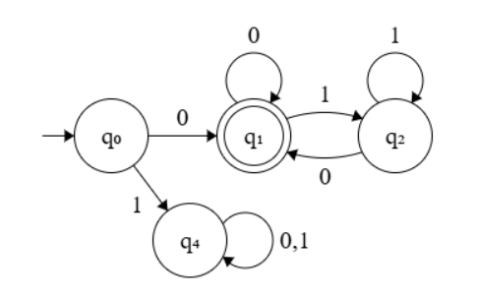

Set A | Set B
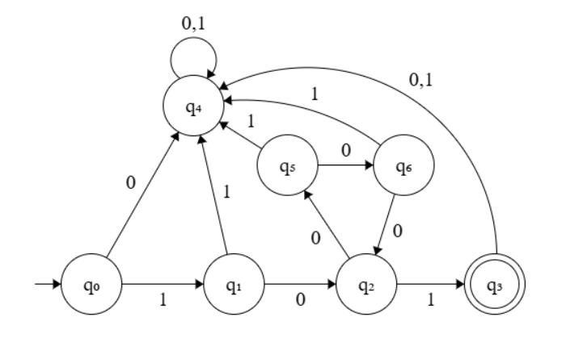  - 10001, 11111  - 3 x 4 x 7 = 84 | f)  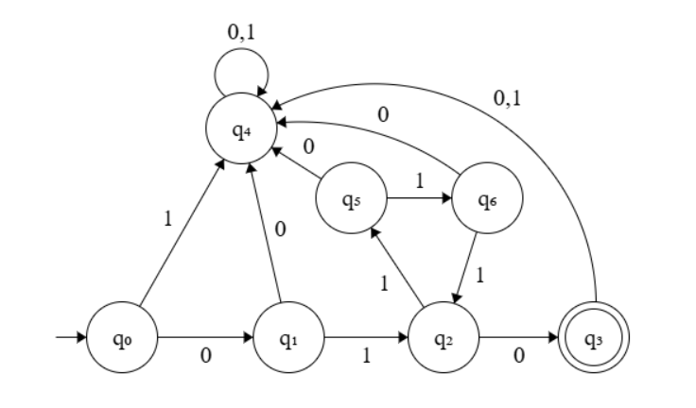  g) 01110, 00000  h) 3 x 4 x 7 = 84

